Spelling Bee

Stevenson PTA proudly presents
Stevenson Elementary’s
4th Annual Scripps National Spelling Bee
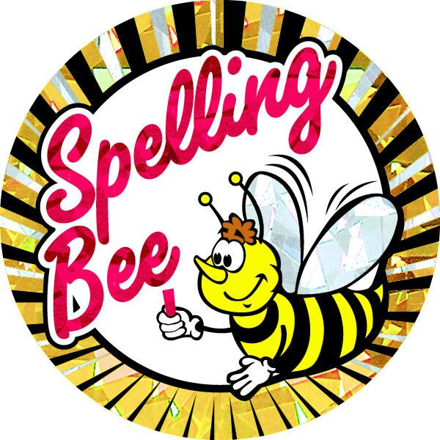
For 1st to 5th grades
Kindergarten students can participate but cannot advance per scripps rules
Compete with the best spellers in school!
Only one student will be picked to compete in district, state and national level!
^{Questions?}
email: Arti Kulkarni @ arti1akolkar@yahoo.co.in or visit: www.stevensonpta.com
_________________________________________________________________________________________
Spelling Bee

If you are interested, please detach, fill out the information below and return to the office with your payment (cash or check payable to Stevenson PTA). You will then be contacted with further information.
Child’s Name: _____________________________________
Name of Class Teacher: _____________________________________
Parents email: _____________________________________

_____I have attached the required $10.00 to participate
_____I have attached what I can afford to pay
_____I have also included a donation to support a student scholarship

*Please include an email address that is checked frequently. You will be emailed weekly with Spelling Bee words to use in your vocabulary along with additional excercises. All are optional but educational and fun!
**There are no refunds permitted

