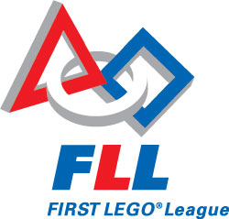
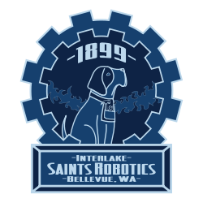
Stevenson Robotics!

Stevenson’s PTA and Interlake Saints Robotics want YOU to join Stevenson’s newest club…
Stevenson Robotics!
- Build robots!
- Work with a team of dedicated mentors from Interlake Saints Robotics!
- Have fun with your friends!
Membership fee: $45 per student
Maximum Capacity: 20 students
When and Where: Mondays 2:30-4:00 in the Café (April 14th to June 2nd)
There will be NO BUS so your student will need to be able to walk home or be picked up by a parent.
Grade level: 4th and 5th grade –and your parent helpers too!
If you are in 4th or 5th grade and would like to sign up, fill out the permission slip on the other side of this flyer and return to the school office by next Friday March 28th, with your payment (checks made out to Stevenson PTA.) Limited to first 20 students who sign up!
This program is made possible by support from PTA and is run by volunteers. Parents, please sign up on the other side of this flyer to help chaperone during Robotics Club for at least one session, thanks!
Questions? Email PTA parent volunteer, Holly Haley, at hollyannehaley@gmail.com

