Donate to Classroom Projects!
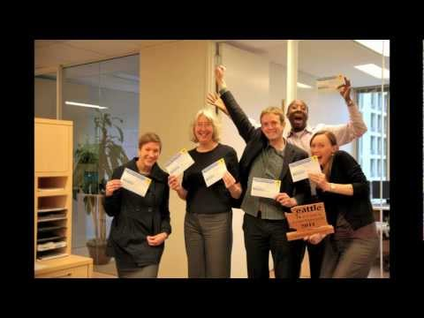 | Play video  On October 5th, everyone who visits a King County Starbucks will receive a free $10 gift card to be used on the DonorsChoose.org website. This website contains thousands of local classroom projects…  00:01:42  Added on 10/04/11  730 views

Stevenson Parent to Parent Newsletter

Stevenson Parents Event Schedule  Go to Starbucks for Gift Card!  Volunteer for Lunch Patrol | Go to Starbucks Tomorrow, Oct 5, to Help Stevenson Teachers!  Here is how it works:  Beginning October 5 (tomorrow) anyone can stop by any King County Starbucks store to pick up a $10 DonorsChoose.org gift card. These FREE gift cards can be redeemed at www.donorschoose.org/kingcounty2011 , where you can choose to apply your card to any of a list of teacher requests for needed classroom materials.  Four Easy Steps:  There are eight projects from Stevenson currently awaiting funding. To spend your gift card on Stevenson:  1. Drop by Starbucks and ask for the DonorsChoose gift card.  1. Visit www.donorschoose.org/kingcounty2011.  2. Enter your gift code.  3. Choose Washington State, Bellevue, Stevenson, and then one of our teacher's classroom projects!  The participating teachers are: Ms. Wong, Ms. Wallendahl, Ms. Wulbert, Ms. Hemming, Ms. Gable, and Ms. Dews.  Remember, even if your child is not in one of those classes, getting money this way for these classes means the school does not have to buy these items, so the school budget will go further for all the students.  More information:  If you would like to see a video on how to do this, please look at  http://youtu.be/dderkCopxiU  The money for these gift cards is coming from the Bill and Melinda Gates Foundation, with help from Starbucks and DonorsChoose.org.  Lunch and Recess Patrol Volunteers Needed  Calling all Parents, grandparents, and caregivers! Come volunteer for lunch and recess patrol! The kids love to have you visit during this time.  Young children are always welcome and speaking English is not necessary. Click on the following link to schedule the day and time most convenient for you.  http://tiny.cc/5prql  You are required to do a onetime background check by filling out and bringing the following form with a photo ID to the front desk.  http://tiny.cc/6xf8y  For further information, email Fatema Musazay at fsaber@uw.edu.  Thank you.

