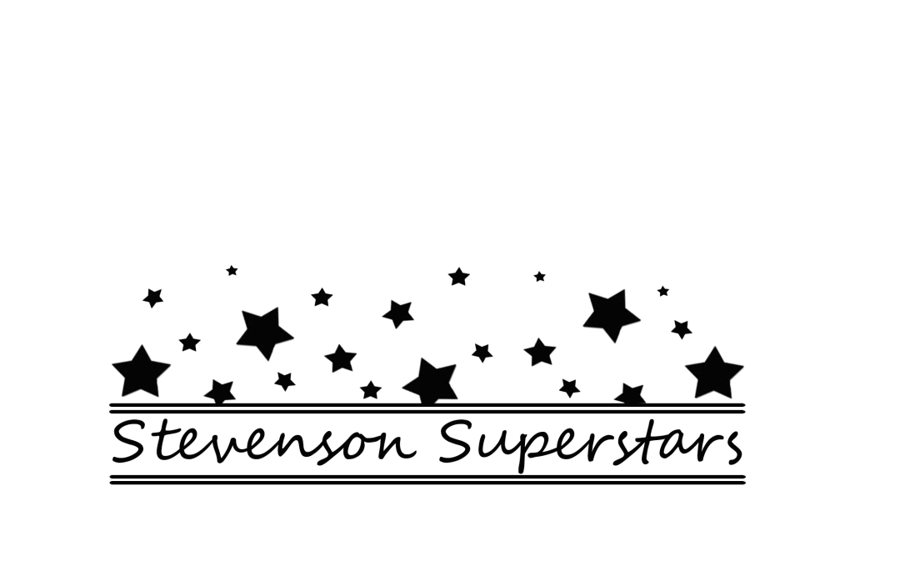
Don’t let your child be left out on Fridays anymore!

Please complete this order form and return it, with your payment, to the office. Checks should be made payable to Stevenson PTA (cash also accepted).

Childs Name _____________________________________
Teachers Name __________________________________

Every Friday is Stevenson Spirit Wear Day – all children are encouraged to wear a Stevenson Spirit shirt or color. Please submit payment by January 6th, 2012

The Stevenson PTA would like to order T-shirts for delivery in January of 2012. The T-shirts will be blue with the above logo on the front, in white.
I have enclosed $6.00 to order a spirit t-shirt for my child

I have enclosed what I am able to contribute toward a spirit t-shirt for my child

I have enclosed an additional donation to assist buying a spirit t-shirt for another child

I am a parent and would like to purchase a spirit tshirt for myself. I have enclosed an additional 10.00 for each adult shirt and need size
small medium large xlarge

